20TH ANNUAL OHIO AREA
CA FUNDAY
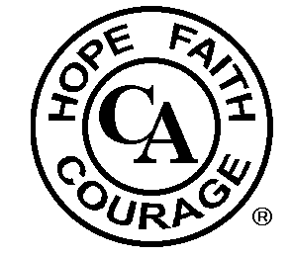

www.caohio.org
MOHICAN CANOE LIVERY
RT. 3 IN LOUDONVILLE, OHIO
AUGUST 6, 2022
Raffle for fun packets to be drawn at 12:00 p.m. Don’t be late!!!!

Akron: Take 76 W. to St. Rt. 3 S. (last exit before 71) and follow all signs for St. Rt. 3 going to Loudonville. When you get into Loudonville, continue on Rt. 3 and Mohican Fun Center/Canoe Livery will be past McDonald’s on the left.

Bring chairs & blankets. Optional fun packets can be purchased for approx. $35.00 each. This includes 1 canoe ride down Mohican River, 1 round of put-put golf and 2 go cart rides. These can be purchased individually if desired. New Aerial Adventure Park added that can be used in place of canoe ride. Lots of fun, food, and fellowship. For more info contact Terry D. at 330-283-4105.

In the spirit of Tradition 6 we are not allied with any sect, denomination, politics, organization, or institution.

