Registration  All T-shirts are $25. Pre-sale and event shirts. All hats will be $15. Pre-sale and event.  Larger Size Shirts Please Pre-Order  Pre-sale colors: Red/Metallic Gold  Event: Black/Metallic Silver  Name _______________________________  Address _____________________________  City ___________________________________  State __________Zip __________  Badge To Read _______________________  Area Code/Telephone ________________  E-Mail ______________________________  Registration before April 15th $20.00 ______  Registration after April 15th $25.00 ____  Shirt/Presale or Event/Size _______  Hats ________  Donation For Newcomer _________  TOTAL ENCLOSED ________  Make check payable to  Monday Night Men’s CA Meeting  C/O Kelsey Stowers  227 S Warren Ave  Columbus, Ohio 43204  Cash App  Kelsey Stowers  $powerlessness  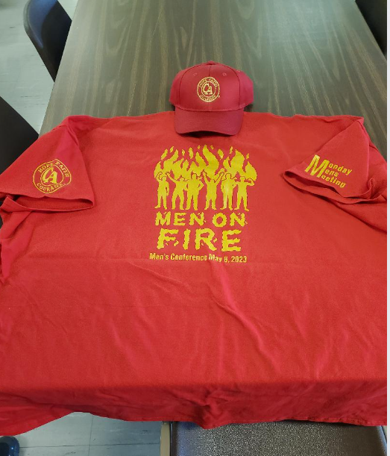 | Monday Night Men’s CA Meeting  Anniversary Presents...  Soaring Sober  Men’s Conference  Saturday, May, 6 2023 1506 E Long St.  Columbus, Ohio 43215  Tradition 6: A C.A. group ought never endorse, finance, or lend the C.A.name to any related facility or outside enterprise, lest problems of money, property, or prestige divert us from our primary purpose. | Itinerary  Registration opens at 9 a.m.  Opening ceremony/speaker @ 10:30  Lunch @ 12p – 1p  First workshop @ 1:30  2nd workshop @ 3p  3rd workshop @ 4:30  Dinner @ 6p  Closing ceremony/speaker 7p  50/50 Raffle  Any vegetarians or vegans please specify for menu adjustments  For more info contact:  Kelsey S. at 614-202-4451  Or email:  mondaymensmeetingca@gmail.com

